

# **The Association of**

## Buckinghamshire Golf Captains

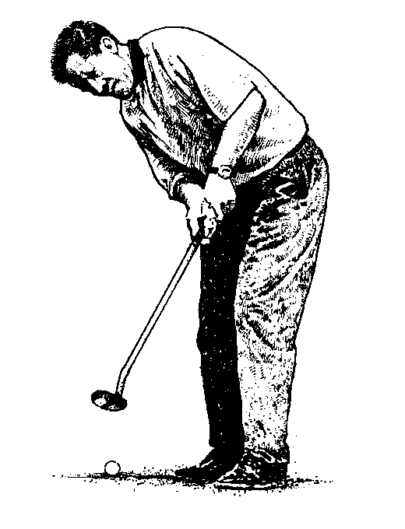

## Captain 2011 – Peter Hill

### Vice-Captain : Roger Warren

### Hon. Secretary : Derek Hill

### Hon. Treasurer : Derek Williams

Newsletter No. 39 January 2011

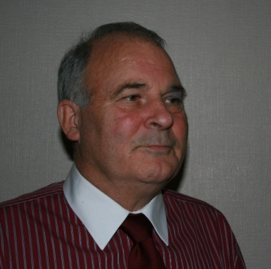CAPTAIN’S CORNER

‘Gobsmacked’ that’s the only word I can think of to describe my feelings when David Carr called me to one side half way around Buckingham Golf Course on his Captain’s Day and asked me if I would consider being proposed to stand for a position on The Association’s Committee.

I have always held The Association of Buckinghamshire Golf Captain’s in the highest esteem and I feel honoured and privileged to be your captain for the coming year.

I would firstly like to thank our committee for all the hard work that they do and know that I can count on their support and advice for the coming season. I would like to welcome Ed Frazier onto the committee, when I first spoke to Ed after his appointment he was so delighted and honoured that he had been voted onto the committee. With all his enthusiasm I’m sure that he will be a great asset to the association.

Peter Short has done an excellent job as Match Secretary since taking over from the very much missed George Axworthy. Peter has tried to drag us into the 20th century and by the end of next season he hopes to propel us into the 21st century. (I am told that we will have a web site!)

The next important event for our association is the Men’s Annual Dinner which will be held on February 25th at Chiltern Forest. It will be impossible to match last year’s dinner at Woburn Golf and Country Club. I feel that as an Association with a Membership second to none, not to mention good wine, etc. We can and will at least match the feeling of friendship and camaraderie that is one of the many strong points of our Association.

On the fixture list front, I hope to accommodate all the members of the society who wish to play in the matches this year. Once again we are going to ask members fill out the form provided to show which matches they are available for and circle their preferred matches. It will obviously not be possible to guarantee members who only make themselves available for a couple of matches, their preferred options.

I will be choosing the teams as early as possible, and encourage you to make a note of the games that you are selected for in your diary. Inevitably there will

be some withdrawals from some of the games. So it would be very helpful if you could indicate on the form the games that you would be available for at short notice.

I intend to resurrect the Dinner Dance this year in conjunction with Association of Buckinghamshire Lady Captains, this is the one and only occasions that the association members are invited to take wives/partners get to take out to socialise with the rest of the Association. I intend asking the Association of Buckinghamshire Lady Captains and their husbands/partners to join us on that evening. The date for the Dinner Dance will be Friday 14th October 2011.

The tour this year will be to South Wales (see separate page)

The new web site/e-mail system allows us to contact each other at no cost to the Association and therefore I intend to use it for the majority of my correspondence this year

I look forward with great pleasure to playing and socialising with as many members of The Association as possible in 2011 and hope that you all had ‘A Very Merry Christmas’ and ‘A Happy New Year’.

PETER HILL

.

#### 

j0292500

**2010 Match Results**

**BEDFORDSHIRE** –Won by 1 Hole

Bedford

**HAMPSHIRE** – Won 5 ½ to 4 ½

Hartley Witney

**NORTHAMPTONSHIRE** – Lost 1 ½ to 6 ½

Kettering

**SOUTH WALES COAST** – Lost 3 ½ to 4 ½

Chiltern Forest

**LONDON** – Lost 4 ½ to 5 ½

Stanmore

**SURREY**– Lost 4 ½ to 5 ½

Surbiton

**WARWICKSHIRE** – Halved

Buckingham

**OXFORDSHIRE** – Lost 3 to 5

Aylesbury Vale

**CAMBRIDGESHIRE** – Won 4 ½ to 3 ½

Royston

**KENT** – Halved

Ellesborough

**HERTFORDSHIRE** – Lost by 3 Holes

Harewood Downs

**SUSSEX** – Halved

Mentmore

j0292500

|  |
| --- |
| **Results of Meetings 2010**  ***SPRING MEETING***  *WINNER- Trevor Murphy 40 pts*  *SECOND – Rod Crisp 39 pts*  ***CAPTAINS AND LADIES***  *WINNERS – Derek Hill & Mary Robertson 46 pts*  *SECOND – Mike Morris & Molly Hunt 45 pts*  *THIRD – John Durban & Mollie Butler 44 pts*  ***FOUR COUNTIES SOUTH***  *Bucks Captains came Second with 188 pts.*  ***CAPTAIN’S DAY***  *WINNER – David Buckingham 43 pts*  *SECOND – Tony Wallington 39 pts*  *THIRD – Douglas Ebdon 37 pts*    ***FOUR COUNTIES NORTH***  *Bucks Captains came Fourth with 173 pts.*  ***AUTUMN MEETING***  *WINNER – John Pettitt 43 pts.*  *SECOND - John Sterling 41 pts ocb*  *THIRD - Mike Morris 41 pts* |

ADMINISTRATION SECRETARY’S NOTES

In starting to look forward to warmer days and the chance to meet up with some old friends in the coming golfing season, we do so with technology advancements in place that will bring the Association right up to date for the 21st Century. Peter Short has been instrumental in establishing a working email system and during the course of this year you will have access to an Association web site that will enable you to view fixtures and results etc. We will make a growing use of email for both match information for playing but also circulation of newsletters which will continue to manage down the costs of running the Association.

It will therefore be very important that any change in your email address is advised to Peter Short as soon as possible and to regularly monitor the information that the Association holds for you. We hope that you will find this additional tool both helpful and interesting and your Committee would of course welcome any feedback that you may wish to give or ideas for improvement.

For 2011 congratulations to Peter Hill on being appointed as our new Captain. Peter, as we all know, is very enthusiastic in his approach to the Association. Also our best wishes go to Roger Warren as Vice-Captain and also Ed Fraser who joins our Committee for the first time. Ian Smithie will of course remain to assist and to pass on his guidance to the new officers. I am sure we will have another very enjoyable year and Peter Hill has already intimated that he wishes to try and re-establish the Dinner Dance in October 2011 and there will be more information on that point during the course of the year. As always the first event of the year will be the Association Dinner which will be held at Chiltern Forest Golf Club on Friday 25th February 2011 and it is to be hoped that as many members as possible will try to attend. You are of course welcome to invite your Club Captain, President, Vice Captain or other officers of your club to join you. Ideally a club table of 8 or 10 people would be most welcome, further details of the evening are to be found elsewhere within this newsletter.

Having successfully tried Aylesbury Vale as a new venue last year, a further new club has been added and we are taking Cambridgeshire to Three Locks in September. A new purpose built visitor facility has been built there which incorporates changing facilities and bar/banqueting suite. We were well received by the management and I am sure this will be a worthwhile addition to our home clubs. The course is of an interesting layout and hopefully will offer a new challenge to a number of you. We have another good range of invites to our away clubs including Southerndown, Burford, Aldwickbury and Royal Blackheath as well as our regular away day in the spring with the venue of Royal Ascot this year. Harewood Downs have been very kind in allowing us to use their facility for the AGM in October.

In my previous report I mentioned some difficulties that were being faced when approaching some of our clubs for fixture bookings. I am pleased to be able to report that many of these have now been resolved; in particular at Gerrards Cross and Beaconsfield, hopefully we will be able to make arrangements with those clubs in the future. The usual fixture selection process with a card for completion will enable the Captain to make team selections during February and once again would ask that you make a note of your selections in your diaries and hopefully thereby avoid the need to search for late replacements when the matches come around. Anyone who is happy for their name to be put on a “short notice” list do please indicate this, as it is of great help. May we also ask members to quote their current club handicap when completing their return.

Peter is planning a tour to South Wales at the end of June for a few days to include Royal Porthcawl so if you are interested in taking part please indicate this on your return and enclose a deposit cheque for £100. This sum is in addition to paying your annual subscription and the cost of tickets for the Men’s Dinner. One cheque will suffice as long as your return in clearly marked to show your requirements

Best Wishes for the New Year to you all and once again do participate and enjoy our days out, look forward to seeing many of you during the year.

Derek Hill

Honorary Administration Secretary

**NEW MEMBERS**

We are pleased to welcome the following members into the

Association and we hope they will enjoy their golf and social occasions with us.

Club Year of Captaincy

Michael Gizzy Gerrards Cross 2010

Terry Willcox Burnham Beeches 2010

|  |
| --- |
| **FIXTURES & FUNCTIONS 2011**  ***Friday 25th February MEN’s DINNER Chiltern Forest*** |
| ***Wednesday 27th April*** ***SPRING MEETING Royal Ascot*** |
| ***Thursday 5th May BEDFORDSHIRE Hazlemere*** |
| ***Tuesday 10th May HAMPSHIRE Harleyford*** |
| ***Wednesday 18th May NORTHAMPTONSHIRE Burnham Beeches*** |
| ***Thursday 2nd June LADIES Whiteleaf*** |
| ***Thursday 9th June SOUTH WALES COAST Southerndown*** |
| ***Sun 27th/Wed 30th June TOUR South Wales*** |
| ***Tuesday 5th July LONDON Flackwell Heath*** |
| ***Wednesday13th July 4 COUNTIES SOUTH Burford*** |
| ***Thursday 21st July SURREY Buckingham*** |
| ***Wednesday 27th July CAPTAIN’S DAY Chiltern Forest*** |
| ***Thursday 4th August FOUR COUNTIES NORTH Gay Hill*** |
| ***Wednesday 17th August WARWICKSHIRE Harborne*** |
| ***Wednesday 24th August OXFORD Kirklington*** |
| ***Thursday 8th September CAMBRIDGESHIRE Three Locks*** |
| ***Thursday 15th September KENT Royal Blackheath*** |
| ***Tuesday 20th September HERTFORDSHIRE Aldwickbury*** |
| ***Thursday 29th September SUSSEX The Dyke*** |
| ***Thursday 27th October AUTUMN MEETING (AGM) Harewood Downs*** |
| ***Also available on www.abc.org.uk*** |

**SUMMER TOUR 2011**

**South Wales – Sunday 26th June to Wednesday 29th June**

Three rounds of Golf Monday through Wednesday

With three nights Bed, Breakfast & Evening Meal ,

lunch at Royal Porthcawl, golf & VAT.

Cost £397 per person based on two people

sharing a twin bedded room. Single rooms + £30.

Courses to be played will be Machynys GC, Ashburnham GC,

Royal Porthcawl & Southerndown.

**£100 Deposit** required by the end of February 2010

to ensure your place

**MENS ANNUAL DINNER**

**Chiltern Forest Golf Club**

**on Friday 25th February 2010 6.30 p.m. for 7.00 p.m.**

**Dress – Dinner Jackets**

This event has proved most popular in the last few years

and is open to members and club guests plus the guests we entertain from the Counties on our fixture list.

TICKETS : price £30 are available from any Committee Member or direct from the Secretary

**Association of Buckinghamshire**

**Golf Captains**

**Committee 201**

**Captain............................................. Peter Hill**

**Vice-Captain.................................... Roger Warren**

**Hon-Secretary..................................Derek Hill**

**Match Secretary...............................Peter Short**

**Immediate Past Captain..................Ian Smithie**

**Treasurer..........................................Derek Williams**

**Clothing Officer...............................Ken Heaver**

**Committee.........................................John Pettitt**

**Committee.........................................Ed Fraser**

**PLEASE MAKE A SPECIAL NOTE OF OUR INTERNAL MEETINGS & ENJOY THE OPPORTUNITY TO MEET MANY OTHER CAPTAINS and PAST CAPTAINS OF BUCKINGHAMSHIRE GOLF CLUBS**

**SPRING MEETING**

**Wednesday 27th April**

**ROYAL ASCOT**

**Golf Club**

**Winkfield Road**

**ASCOT**

**SL5 7LJ**

**CAPTAIN’S DAY**

**Wednesday 27th July**

**CHILTERN FOREST**

**Halton**

**HP22 5NQ**

**Come and support your Captain Peter**

**on his home course.**

**AUTUMN MEETING & AGM**

**Thursday 27th October**

**HAREWOOD DOWNS Golf Club**

**Always a popular course and super food**

**Your opportunity to hear of the Association’s year and put forward your views on our future activity.**