
The Association of
Buckinghamshire
Golf Captains
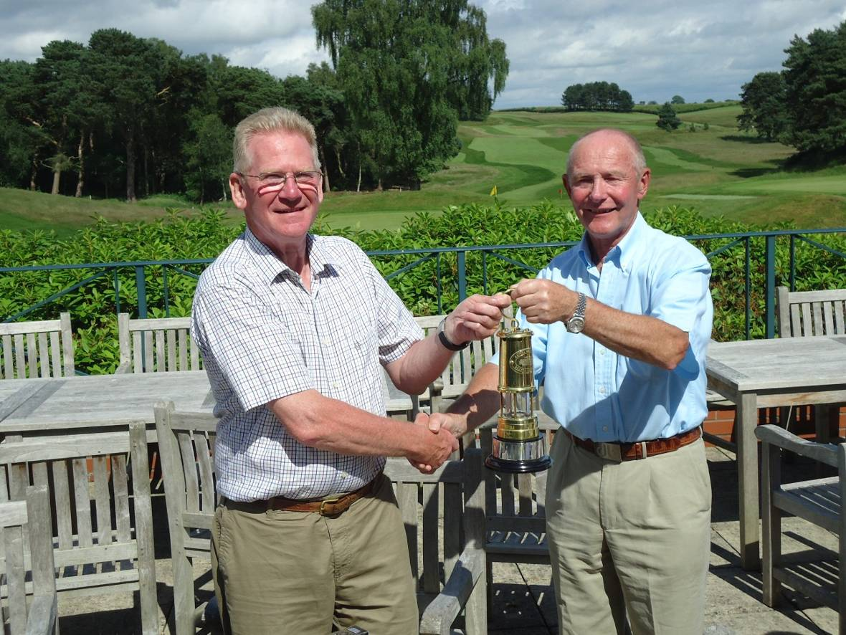
Newsletter 42 SEPTEMBER 2012
IN THIS ISSUE | 2  4  5  11  13  15 | Captain’s Corner  AGM notice  Minutes of the 2011 AGM  Accounts and Treasurer’s report  Admin Secretary’s report  Match Secretary’s report

Captain’s Tour 2012 winner – John Hutchins

Captain’s Corner
I am nearing the end of my Captain’s year that has seen one of the wettest summers but miraculously the weather only interfered with one match. That was at Leighton Buzzard where due to ground conditions we played the front nine holes twice but still lost comprehensively.
Up to the 6 September we have played nine matches with results of: lost three, halved two and won four. Not too bad an outcome considering that your Captain has not exactly led from the front only winning one of his matches and halving another; so far. I shall endeavour to do better in the remaining part of the season. The Four Counties South at Gerrards Cross was won by Oxfordshire with Buckinghamshire second equal. The defence of the Four Counties North cup at Thetford ended in victory for Worcester and third place for Buckinghamshire. However, whatever the results, we have played some very good courses against friendly competition and as always enjoyed the company of fellow past captains.
The tour to the Wirral was, I think, a golfing success with the courses living up to expectations (unlike the hotel which did not). I particularly enjoyed Caldy and Wallasey, but the other two courses at Bromborough and Delamere Forest were also well worth our visit. Congratulations to John Hutchins who won a very close fought contest and the miner’s lamp with a high scoring final round at Delamere Forest.
My Captain’s Day at Flackwell Heath was blessed with really fine weather and a good turnout from the Association and from Flackwell past captains two of whom filled second and third places. It was John Hardcastle however, who is not a Flackwell man, who pipped John Hutchins on the back nine to take the winner’s place on the podium.
I must say that your committee has made my job easy. Particular thanks go to Derek Hill for organising our golfing programme, and to Peter Short for his work as Match Secretary often entailing last minute calls to make sure we have a full team. Thanks also to Derek Williams who continues to do an excellent job as Treasurer, and to other members of your Committee who help to make everything run smoothly. And last but by no means least I thank Ken Heaver, vice captain, for his support at all our fixtures. He has been sweeper, out last at every match to make sure we are all off in good order. But the last shall be first, from next year when I know he will do well as our representative and I wish him well for next year.
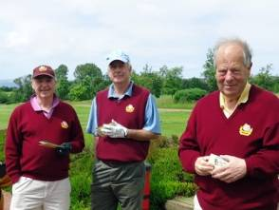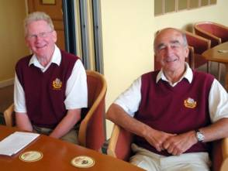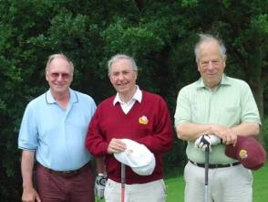
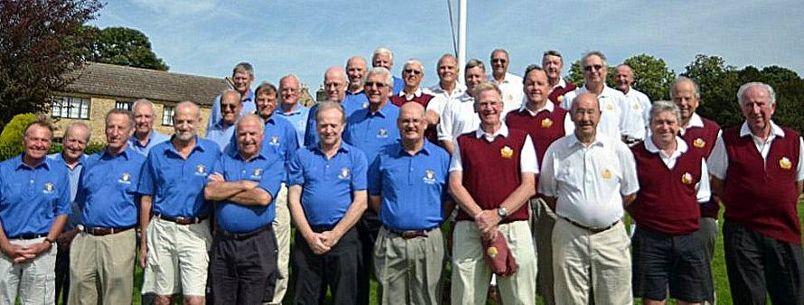
photos from the Cambridgeshire match and other members
I have thoroughly enjoyed my year as Captain of the Association. This has been a privilege and an honour. I have not always been able to pick winning teams, but success is not measured solely by results but by the enjoyment to be had from being part of a team and from meeting like minded golfers in some wonderful locations. I think this is what I shall remember of my year. So I end with a final thank you to all the members who have supported me and the association throughout the last year.
Roger Warren – 2012 Captain

AGM 2012
Notice is hereby given that the 33rd Annual General Meeting of the Association of Buckinghamshire Golf Captains will take place at the Beaconsfield Golf Club on Wednesday 24 October 2012 at approximately 7pm.
Derek Hill – Honorary Administration Secretary – August 2012

Agenda
1 Apologies for absence
2 Minutes of the 32nd Annual General Meeting
3 Matters arising
4 Captain’s report
5 Financial reports
6 Elections of Officers and Committee
Captain: Ken Heaver, proposed by Roger Warren, seconded by Derek Hill
Vice-Captain: John Pettitt, proposed by Ken Heaver, seconded by Ed Fraser
Honorary Secretary: Peter Short, proposed by Derek Hill,
seconded by Peter Hill
Honorary Match Secretary: Peter Short, proposed by Peter Hill,
seconded by Doug Ebdon
Honorary Treasurer: Derek Williams, proposed by Roger Warren,
seconded by John Pettitt
Committee: Ed Fraser, D Ebdon, J Hardcastle, proposed by Derek Hill, seconded by Ken Heaver
7 Any other business

Association of
Buckinghamshire Golf Captains

Minutes of the 2011 AGM
held at Harewood Downs Club on 27 October 2011
PRESENT
Peter Hill (Captain), Roger Warren (Vice-Captain), D Hill (Hon Secretary),
D Williams (Treasurer), P Short (Match Secretary), K Heaver, J Pettitt, Ed Fraser and 52 members.
The Captain opened the meeting and welcomed members to the AGM.

APOLOGIES FOR ABSENCE
The Secretary read out the names of 8 members who had apologised: K Camp,
D Yorke, M Morris, M Smith, A Taylor, D McMullan, A Kirkpatrick and I Smithie.
Minutes of the previous AGM (31st) held at Denham Golf Club on Thursday 28 October 2010. The Secretary had reported that these had been circulated to all members in Newsletter 40 and further copies were available if required. Therefore these minutes would not be read out unless requested.
As there were no requests, the Captain asked for approval of these minutes
as a true record. Proposed by Phil Price and Seconded by D Balfour approved unanimously.

CAPTAIN’S REPORT
Dear friends as that is how I now think of the members of Bucks Captains, I wish you all a very warm, if belated, welcome to Harewood Downs this afternoon, especially those who are new members of our association. It has been a real pleasure in representing, you and our Association at the matches and the two Four Counties games that we played this year.
I have attended all the county dinners and have, with either Derek or Peter, represented the association with great pride.
The final result of the matches were 1 halved, 6 lost and 5 won.
The results of the four “Four Counties Games” that we played were:
Runners up to the third team out of four at the Four Counties South game at Burford in Oxfordshire; this with what I thought was a very good side!
We then moved on to Gay Hill near Birmingham, I don’t know what Derek was thinking when he okayed that fixture, but as both of our surnames as you know are Hill having to play at Gay Hill and then the Dyke had certain connotations, so I’m led to believe!
I was very surprised to be told half way through dinner that we had won the Four Counties North competition, and that I needed therefore to prepare myself to accept the trophy and say a few words. This I did with great pride. Well done to that team! So over all I think that we have had a very successful year and I thank all of you, who have played for the association this year. The two Tony’s that’s Simpson and Jeffries, have played the most matches and I would like to thank them for stepping into the breach at late notice, as they often did.
The tour of Wales was, I think, a great success. Roger Warren (You will be hearing from him later) won the golf. Jim Begley (I heard from him for about 5 hours every night) won the snoring competition and John Ketley as usual came first in the story telling stakes.
My thanks must now be given, and in no particular order
(so I’ll do it alphabetically)
To, Derek Hill for all his secretarial work including next year’s excellent fixture list, as well as the help that he has given me this year (thanks Dad)!
To, Derek Williams for the way in which he has handled the accounts
again this year.
To, Ken for keeping us suited and booted.
To, Ian (the immediate past Captain) for his support and advice
To, Peter for the way in which he has taken over from George, who if he is looking down on us will be looking over Peter’s shoulder and trying to see how the computer works.
We had the correct number at the correct venue on the correct day at approximately the correct time for all our matches.
I think that you will all agree that in addition the work that Peter has done on our web site (www.abgc.org.uk) has been outstanding.
To, Roger for all the support that he has given me this year, and the work that he has done behind the scenes. Have a great year next year Roger
To John and Ed the remaining two members of your committee, who I’m sure must have done something this year.
The year has sped by and once again I must say what a privilege it has been for me to be your captain.
I would now like to move things forward and ask Derek Williams to present his financial report.

FINANCIAL REPORT
The Treasurer, Derek Williams pointed out that his report and Statement of Accounts is shown in the Newsletter. The Treasurer was happy that the match fee could be retained at £50 for a further season. No questions arose and the Captain thanked Derek for his report and asked for approval. Proposed by John Pettitt, seconded by Roger Harman and carried unanimously.

ELECTION OF OFFICERS & COMMITTEE 2011

CAPTAIN
The Captain introduced the Captain elect Roger Warren from Flackwell Heath Proposed by Peter Hill and seconded by Ian Smithie retiring Immediate Past Captain.
Approval for the appointment was sought from the membership present and carried unanimously. The chain of office was duly handed over to Roger Warren.
The new Captain thanked Peter for all his efforts during the year and for making 2011 so enjoyable, and presented the Past Captains Badge to the outgoing Captain.

VICE-CAPTAIN
The Secretary read the nomination – Ken Heaver, proposed by Roger Warren and seconded by John Pettitt. The Captain asked for approval. Carried unanimously.

HON SECRETARY
The nomination is – Derek Hill proposed by Peter Hill and seconded by Peter Short. The Captain asked for approval. Carried unanimously.

HON MATCH-SECRETARY
The nomination is – Peter Short proposed by Derek Hill seconded by Ed Fraser. The Captain asked for approval. Carried unanimously.

HON TREASURER
The nomination is - Derek Williams proposed by Peter Hill seconded by Ken Heaver. The Captain asked for approval. Carried unanimously.

COMMITTEE: 3 NOMINATIONS
John Pettitt – proposed by Peter Short, seconded by Roger Warren.
Ed Fraser – proposed by Peter Short, seconded by Roger Warren.
Doug Ebdon – proposed by Peter Short, seconded by Roger Warren.
There were no nominations from the floor so the Captain asked for a block vote and all were duly elected.
The Retiring Captain Peter Hill remains on the Committee for a further year.
Roger Warren thanked the members for electing him and looked forward to another successful year with the Captains and working with the new Committee welcoming Doug Ebdon to his new role.

ANY OTHER BUSINESS
In an attempt to give everyone as much playing time as possible, Members were asked to consider whether a fourth internal event was worthy of consideration. The general view was there was no great demand for such an event and the matter would be left to the Committee decision.
Members have been supplied with newsletter and information by way of email for the first time this year and Members were asked as to whether they were happy to continue in this format. All well received and both newsletter, handbook and fixture list will be produ8ced in this format going forward.
The Secretary gave a preliminary run down of next year’s fixtures as far as was practicable which included the Spring Meeting at Redbourne the AGM at Beaconsfield, with matches at Burnham Beeches, Cams Hall, Ramsey and Strawberry Hill. Men’s Dinner plus Captains Day being at Flackwell Heath. The tour for 2012 will be to The Wirral, details to be advised in the January Newsletter.
The Association continues to receive the occasional jacket from retiring members and these will continue to be made available for resale when possible.
There being no other business the Captain closed the meeting and advised members that the 33rd ANNUAL GENERAL MEETING will be held again at Beaconsfield Golf Club on Wednesday 24 October 2012.

For your notes

Statement of Accounts
Year ended 31 August 2012
RECEIPTS | 2012  £ | 2011  £ | EXPENDITURE | 2012  £ | 2011  £
Subscriptions | 2896 | 3,024 | Administration expenses | 867 | 1,519
 |  |  | Loss on Men's Dinner | 1,118 | 556
Interest | 2 | 2 | Ball sweep Surplus, less costs | 212 | (139)
Profit on sale of clothing | 147 | 369 | Loss on Dinner Dance | 0 | 0
 | 3,045 | 3,395 |  | 2,197 | 1,936
Surplus on matches:
Internal Meetings: | 835 | 962
Receipts less costs: | 3,317 | (3,848) | Profit/(Loss) for the year | 5,000 | -1,427
 | 7,197 | 509 |  | 7,197 | 509
 |  |  | BALANCE SHEET AS AT 31 AUGUST 2012
 |  |  | Bank balances | 15,812 | 10,011
 |  |  | Clothing Stock | 2,627 | 1,618
 |  |  | Other Stock | 0 | 330
 |  |  |  | 18,439 | 11,959
 |  |  | Sundry Creditors | (1,680)
 |  |  | Deposits prepaid | 300 | 100
 |  |  |  | 17,059 | 12,059
 |  |  | Reserves brought forward | 12,509 | 13,486
 |  |  | Profit/(Loss) for the year | 5,000 | -1,427
 |  |  | Reserves carried forward | 17,059 | 12,059

Treasurer’s report
The surplus for the year ended 31st August 2012 of £5,000 must be regarded as satisfactory in view of the continuing decline in membership numbers. Annual subscriptions for the period were £128 less than in the previous period. The administration costs were £650 less than previously, partly due to the greater use of the internet over postage costs. However, this saving was almost entirely offset by the larger loss on the Annual Dinner.
On matches and competitions, a healthy surplus of £4,152 was achieved, largely due to the greater number of away matches played. It was noticed, however, that the cost per head charged by Clubs hosting our home fixtures ranged between £53.15 and £56. The Committee will need to consider an increase of the match fee for the next season.
Derek Williams – Treasurer

New Members 2012
We are pleased to welcome the following members into the Association
and we hope they will enjoy their golf and social occasions with us.
MEMBER | CLUB | YEAR OF CAPTAINCY
Brian Donnely | Chiltern Forest | 2011
Graeme Forrester | Ellesbrough | 1995 Renewing Member
Dalbinder Khatkar | The Lambourne Club | 2011
David Liston | Oakland Park | 2011
Bob Gilmour | Oakland Park | 2008

Administration
Secretary’s report
The golfing year seems to pass ever more quickly and it is difficult to believe I am again writing a year-end report albeit with still a few matches remaining. Once again another enjoyable year under the leadership of our Captain Roger Warren, with great fun enjoyed by all that have had the opportunity of participating.
Once again I encourage you all to speak to the Captains both present and past from your Clubs and encourage them to come and join us as our numbers are still less than we would prefer and always welcome some new blood to our Association.
Peter Short has once again given full support to the Association and thanks are expressed to all those that have filled the gaps at short notice.
The website is now an integral part of our activities and we are now using this means of communication as a regular vehicle so it is important that your correspondence address is kept up to date and that you report any difficulties as soon as they arise. Some hiccups were experienced at the beginning of the year when a few individuals were not able to either receive or open the communication. The system is only as good as the information contained therein.
The Captain will have commented on the team’s performance during the year and the events that we have attended on behalf of the Association. The enjoyable Annual Dinner at Flackwell, his successful Captains Day and the Spring Meeting at Redborne are all worthy of comment and our thanks go to the Clubs who have continued to support our Association.
Looking forward to next year the fixture list is in course of preparation and we will of course be at Mentmore for the Annual Dinner and Captains Day given that Ken Heaver will be standing as Captain for 2013. We already have booked East Berks for the Spring Meeting and are in discussion with Gerrards Cross for the AGM in October albeit the start time will need to be somewhat earlier. South Wales are taking us to Newport and one of the Four Counties will be at Old Fold Manor. A full list of the events will be made available at the Annual General Meeting. A tour will also be advised once the Vice Captain has finalised his plans.
We continue to encourage members to use the standing order system to pay their annual subscriptions which are being held at their present level at £20, details and forms for use are available on the website. Renewal date continues to be 1st February annually.
Doug Ebdon has assumed the role of clothing officer for the next period and members are encouraged to contact him with their clothing requirements. Email and telephone numbers for Doug are on the website.
Should there be any past members known who wish to dispose of their Association jackets please let us know and will make a nominal payment for the jacket if required.
It is with pleasure that we are able to advise members that John Hardcastle from Chesham & Ley Hill has agreed to stand for election to the Committee at the Annual General Meeting and would extend our best wishes to him. Peter Hill is due to stand down as Immediate Past Captain but has offered to assist Peter Short in his role of Match Secretary. Peter Short is proposed as Administration Secretary with yours truly standing down from the Committee after a period of 12 years in the role. My grateful thanks to all members for their support over the years their comradeship, good banter and some memorable days out. I have worked alongside some great guys who have worked for the Association in all capacities and have to say have enjoyed every minute. Best Wishes to you all and will continue to attend meetings whenever possible.
Good Luck to you all.
Derek Hill – Secretary

Match Secretary’s report
It’s been a difficult year with members withdrawing from matches at the last minute with nearly every match being affected. I have had to implement the 7 day £25 rule seven times so far. Of course no one does this without good reason and I fully understand we are more prone to illness and back problems at our age. So please let me know as soon as possible if you may have to withdraw as it makes it easier to find a replacement.
Most of you are using the web site, but I still get calls asking if you are playing in a particular match or not. I do update the site on a daily basis, so the teams are always up-to-date.
We currently have 150 members, which is quite low compared to other associations. Our database of members gives me easy access to all your email address, home addresses and phone numbers which you can get from the Members’ Handbook at www.abgc.org.uk/memberdownloads.php Also on this page you can see this, previous newsletters, association forms and other documents.
For the 22 of you without computers I will continue to send you everything by post. If you do get a computer / laptop / tablet in the meantime, change your email or other contact details, please let me know.

Peter Short – Match Secretary

Autumn Meeting and AGM at Beaconsfield
Invitations have been sent out, but if you just wish to attend the AGM / Dinner the cost is £25. Please let Peter Short or Derek Hill know as soon as possible!

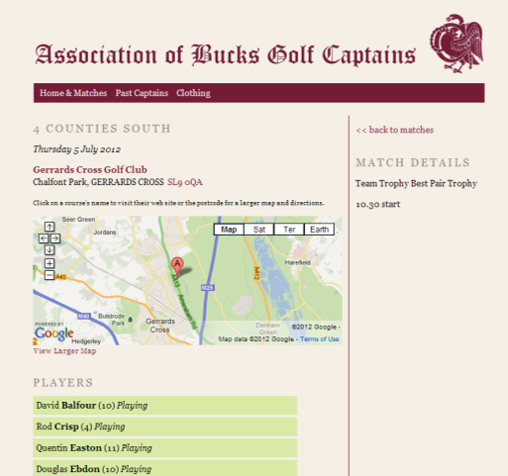
www.abgc.org.uk
Hints and tips
Newsletter 42, October 2012
written by Roger Warren, Derek Hill, Derek Williams and Peter Short
cover photo by Gordon Bull
designed by Tony Short – tony@tomodomo.net
www.abgc.org.uk
©2012 The Association of Buckinghamshire Golf Captains

Get more club information
Clicking on the club name will get you to the clubs web site if you want to get more info, contact them or look at the course and facilities.

Get directions
Have you tried clicking on the club address postcode when looking at a match? You will be linked to Google maps where you can print out maps or get driving directions to the club.

Are you on the team?

The Players section shows clearly who is playing and the reserves. This is updated daily and so the best place to find out if you are in the team. You can also use this to arrange lifts to the match.

