
The Association of
Buckinghamshire
Golf Captains
Newsletter 43 JANUARY 2013
IN THIS ISSUE
2
5
5
6
7
9
10Captain’s Corner
Match results 2012
New members
Results of meetings 2012
Admin Secretary’s notes
Fixtures and functions 2013 Website
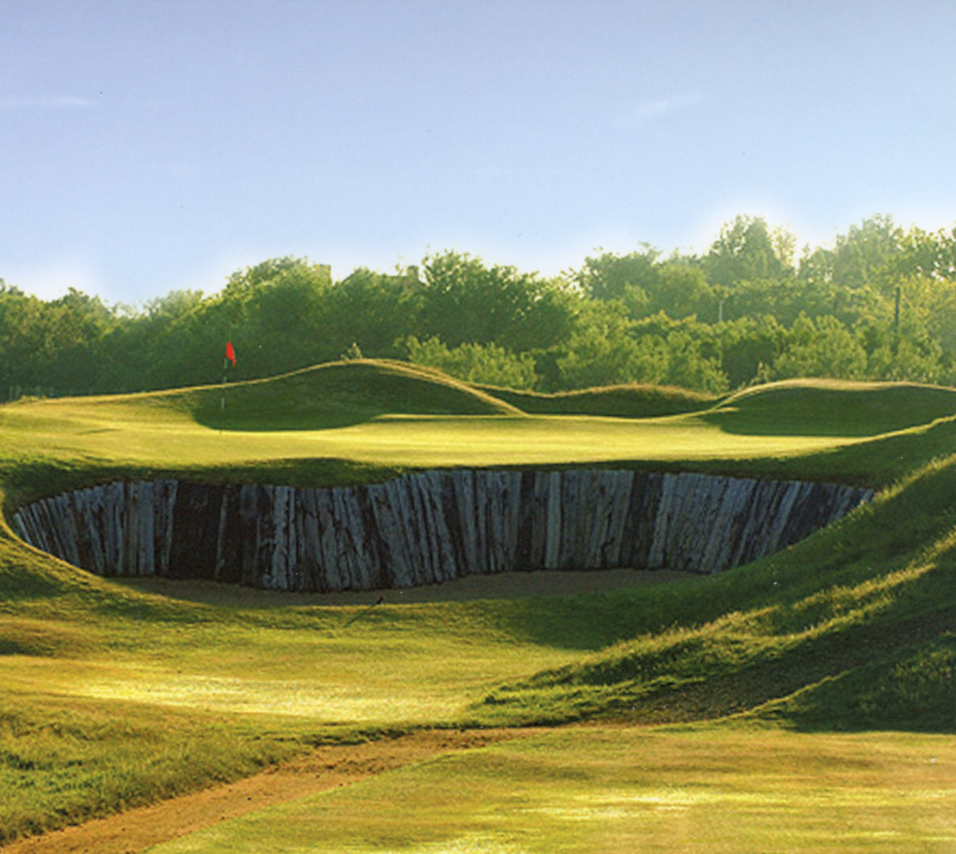

Here’s hoping for a
LUCKY ‘13 for golf!
7th at Hunstanton Golf Club – Play this on the Captains Tour!

Captain’s Corner
A very “Happy New Year” to you all. It was a great honour for me to be elected by you to be your Captain for 2013. I will do my best to keep the Association at the high level that my predecessors have achieved. If at the end of the season you can say that you have enjoyed your golf with the Association then I will have succeeded.
The autumn meeting at Beaconsfield was well attended and was Roger’s farewell as Captain. We congratulate him on a very successful year even if his personal form suffered for much of the year. I’m told that some very good partners eased the burden in many of his matches. Thank you, Roger, for all your hard work that enabled us all to have a very enjoyable year.
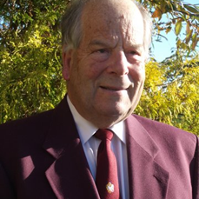

Ken Heaver
Captain 2013
This year has seen the end of an era. Derek Hill decided to call a halt to his time as Secretary of the Association after a 12 year stint. He has kept the Association on a strong basis over that period when many changes in methods of communication have been occurring and there have been unprecedented pressures on finance. We are very grateful, Derek, for all the hard work that you have put in over the years keeping us on the straight and narrow. As a token of our appreciation Roger made a presentation of a cheque to Derek that we understand is going to be used to purchase photographic equipment. His expertise will not be lost completely because he is still going to be arranging the fixtures in the immediate future.
It was a partial farewell for Peter Hill as well. As past Captain he leaves the Committee this year and we welcome John Hardcastle in his place. Welcome John, to the Committee and I’m sure that you will find the experience very enjoyable. Unfortunately, Ed Fraser has had to resign from the Committee. He is in the process of returning to Inverness to live and feels the commute might be a trifle far. We will miss you, Ed, but look forward to you staying on the Committee until your moves takes place.
John Pettitt becomes my Vice Captain for next year and I wish him well and good golf. Tail-End-Charlie in the matches is a very important role, if only to collect the outstanding monies and win!
Peter Short is becoming our full time Secretary. He has done a fabulous job dragging us kicking and screaming into the Internet age. The web site has been tremendous and we await future developments on it. Peter and Derek Hill are assisting where required and you may find that Match Secretaries are nominated for specific matches to ease the burden on Peter. The availability list is as always included with the fixture list. Please return your preferences as soon as possible because Peter and I need to establish the teams before March. I will do my best to accommodate as many of you as possible but please remember that if you only request one game you are unlikely to be picked for that particular match if it is a popular venue.
Finance is a growing problem. Our Treasurer, Derek Williams, has done his usual immaculate job but there is a stress on our funds. Although we appear to have a strong fund at present our home matches are not breaking even, hence it was felt prudent to increase the price to £55. The internal meeting where wine on the table is not provided remain at £50.
The fixture list for next year contains the usual mixture of good attractive courses and some not so well. I hope that you make the effort at the beginning of the Season and come to East Berks, which definitely comes in the first category. The tour this year is to North West Norfolk in June. The highlight will be a round at Hunstanton Links renowned as one of the best links in England never to have held the Open. Four rounds of golf are included at four different courses and the cost is below £400 per person staying at Heacham Manor. We are limited to 20 members so please reply as soon as possible to book a place and not be disappointed.
The first event of the year is the Men’s Dinner on the last Friday in February, this year to be held at Mentmore. I hope that you will all make the effort to come to this annual function. I’m assured the Speaker, will be excellent to make a good evening. Guests are welcome on the night so why not bring your Secretary or Professional or both.
Finally I wish you all success on and off the Course during 2013 and look forward to seeing and playing with as many of you as possible during the year.
Ken Heaver – Captain 2013
Men’s Dinner  Friday 22 February 2013  7pm for 7.30pm Dinner Jackets  Tickets are priced £35 and are  available from any Committee Member  or direct from the Peter Short, Secretary | Please support this event which is open to all members and club guests, plus the guests we entertain from the Counties on our fixture list.

Match results 2012
AGAINST | AT | RESULT
Bedfordshire | Leighton Buzzard | Lost 19 down
Hampshire | Cams Hall | Won 5.5/4.5
Northamptonshire | Wellingborough | Won 5/3
South Wales Coast | Lambourne | Won 5.5/2.5
London | Strawburry Hill | Lost 6/4
Surrey | Bansted Downs | Drew 5/5
Warwickshire | Mentmore | Won 4.5/3.5
Oxfordshire | Buckingham | Drew 4/4
Cambridgeshire | Ramsey | Lost7/1
Kent | Burnham Beeches | Won 6/4
Hertfordshire | Three Locks | Won 17 up
Sussex | Ellesborough | Won 4.5/3.5

New Members
We are pleased to welcome the following members into the Association and we hope they will enjoy their golf and social occasions with us.
MEMBER | CLUB | YEAR OF CAPTAINCY
Keith Byant  Jonathon Larrett  Gerry McSloy  John Pool | Burnham Beeches  Three Locks  Gerrards Cross  The Lambourne | 2012/3  2012  2012/3  2012
Results of
meetings 2012

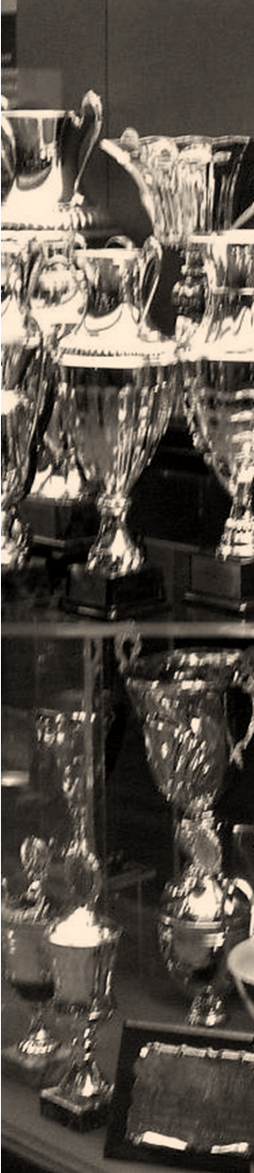
Spring Meeting at Redbourne
Winner – Brian Rodgers 34pts ocb
Second – Doug Ebdon 34pts

Captains and Ladies at Whiteleaf
Winners – Keith Emery and Jane Burns 44pts
Second – David McMullan and Pauline Slater 43pts
Third – Nick Rathbone and Margaret Maisey 42pts

Four Counties South at Gerrards Cross
Bucks Captains came equal second with 203pts

Captain’s Day at Flackwell Heath
Winner – John Hardcastle with 37pts ocb
Second – John Hutchins with 37pts
Best Gross – Roger Gillam

Four Counties North at Thetford
Bucks Captains came second with 192pts

Autumn Meeting at Beaconsfield
Winner – Jim Begley with 44pts
Second – Brian Lowe with 43pts
Third – Rob Southerden with 41pts

Administration and Match
Secretary’s notes
I must start by endorsing Ken’s comments about Derek Hill. He has done a sterling job over the past 12 years and has already been very helpful to me in taking over his role. He will however continue to be a prominent role in our Association and is already organising the Men’s Dinner at Mentmore
with me.
I wish you all Best Wishes for the New Year and a successful golfing year under the leadership of our new Captain Ken Heaver. I know he is looking forward to it and it will keep him very busy in 2013.
One of the concerns of the Committee over the past 2 years is the decline in membership. In 2012 we lost 21 members and only recruited 11. We are not alone in this and some Counties have had to cut costs to cover the losses. I have been told that in April 2012 the BB&O lost 6000 members from the previous year so it appears to becoming a real problem particularly with the average age of participating golfers also increasing. We invited the club captains to all our home matches last year and this has helped in our recruitment, however I am now encouraging all of you to try and persuade your current and past captains to join the Association. You could download a membership application from the website and personally give it to your colleague, or get him to look at the website and see what he can get from being a member.
Looking at the season ahead, you will also get with this newsletter the annual booklet, the usual fixture details with the request that you indicate your interest in the respective fixtures by marking the adjacent boxes and where able, give some indication that you might be available at short notice, as this is so important when I have to deal with late withdrawals. We will ensure that everyone gets a game.
You are also asked to pay your renewal fee for the season and there is a standing order form available on the website for this to make it a little bit easier for the Treasurer. The returns will be used as the basis of team selection early in February and if you wish Ken to consider you please ensure you respond by the end of January. It is suggested that you enter your requests in your personal diary to avoid the chance of double bookings and the need to consider cancelling if selected later in the year.
Finally please contact me if you have any concerns, issues or requests and I will do what I can to ensure the continuing smooth running, tradition and success of the Association.
Peter Short – Secretary

Summer Tour  2013  North Norfolk  Sunday 23 June to  Wednesday 26 June  www.club-noticeboard.co.uk/swaffam  www.hunstantongolfclub.com  www.heacham-manor.co.uk  www.club-noticeboard.co.uk/kingslynn | Four rounds of golf Sunday afternoon to Wednesday morning Swaffam, Heacham Manor, Hunstanton and  Kings Lynn  Three nights bed, breakfast and evening meal at the Heacham Manor Hotel  Cost £385 per person based on two people sharing a twin bedded room.  Superior room for +£30pp  Single supplement + £35  £100 deposit required by the end of February 2013 to ensure your place. Please send payment to Peter Short, Secretary

Fixtures and functions 2013
Please make a special note of our internal meetings* and enjoy the opportunity to meet many other Captains and Past captains of Buckinghamshire golf clubs.
DATE 2013 | FIXTURE | A
Friday 22 February | Men’s Dinner | Mentmore
Thursday 25 April * | Spring Meeting | East Berkshire
Wednesday 8 May | Bedfordshire | Ellesborough
Monday 20 May | Hampshire | Burnham Beeches
Thursday 23 May | Northamptonshire | Harewood Downs
Tuesday 28 May | Ladies Match | Lambourne
Thursday 13 June | South Wales Coast | Newport
Monday 17 June | Surrey | Hazelmere
Sun 23- Wed 26 June | Summer Tour | NW Norfolk
Friday 5 July | London | Chesham and Ley Hill
Wednesday 10 July | 4 Counties South | Frilford Heath
Wednesday 24 July * | Captain’s Day | Mentmore
Friday 9 August | Cambridgeshire | Weston Turville
Wednesday 14 August | 4 Counties North | Old Fold Manor
Thursday 15 August | Warwickshire | Copt Heath
Wednesday 21 August | Oxfordshire | North Oxford
Tuesday 17 September | Hertfordshire | Chesfield Downs
Friday 20 September | Kent | Canterbury
Wednesday 25 September | Sussex | Willindon
Friday 25 October * | Autumn Meeting & AGM | Gerrards Cross
Your opportunity to hear of the Association’s year and put forward your views

Web site
I am sure you are all now using our web site www.abgc.org.uk
All the matches and associated information for the last 3 years can be seen, as well as all the matches for 2013. When the teams for 2013 are chosen from your returns all invitees and reserves will also be shown. Additionally you can also browse the official club clothing, view a list of past ABGC captains, and download a Standing Order form for your subscription. Newsletters from 2010 and the annual booklet can be seen on the download link www.abgc.org.uk/memberdownloads, but I am planning to give all members a logon direct to this page during 2013.
Peter Short –Secretary

Newsletter 43, January 2013
written by Ken Heaver and Peter Short
designed by Tony Short – tony@tomodomo.net
www.abgc.org.uk

©2012 The Association of
Buckinghamshire Golf Captains

